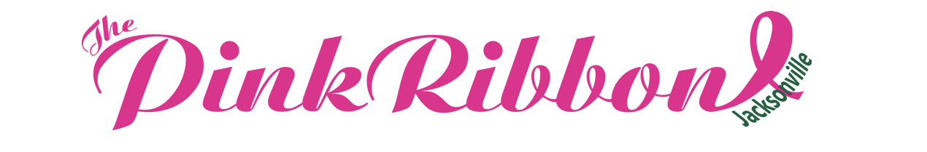

– Pink Ribbon Friends –
as of October 19, 2020

Pink Ribbon Friends: $500
First Coast Mohs, Scott Warren
Susan Garvey
Sharon & David Hunt
Monica Jacoby
Christopher Luca
Helen Short
Martha & Leonard Stachitas
Nick van Olden
Camilla & Charles Wodehouse
Linda & Glenn Wolfson

--------------------------------------------------------------------------------

Pink Ribbon Friends: $250
Susan M. Bledsoe
Susie Buckey
Michelle & William Burgstiner
Rushton Callaghan
Champion Roofing Services, Inc.
Debbie & Bill Dunn
Charlotte & Gary Ehlig
Susan Goodall
The Grimes Companies
Nancy & R.O. Kaufman
Kimberly & Randal Nader
Margaret & Vaugh Nixon
Shirley Patterson
Chester Roberts
Gina & Dean Simmons
Susie & George Spiel
Julie Taylor
Total Distribution
UCW Logistics, LLC
Pamela Veth

